МОСКОВСКИЙ ГОСУДАРСТВЕННЫЙ ТЕХНИЧЕСКИЙ УНИВЕРСИТЕТ  
им. Н.Э. Баумана

Факультет "Информатика и системы управления"  
Кафедра "Системы обработки информации и управления"



Дисциплина "Парадигмы и конструкции языков программирования"

Отчет по домашнему заданию

"Приложение для сортировки пикселей фотографии"

**Выполнил:**  
Студент группы ИУ5-35Б  
Королев М.О.  
**Преподаватель:**  
Гапанюк Ю.Е.

Москва 2025

**Постановка задачи:**

1. С помощью DearPyGui разработать графический интерфейс состоящий из "холста" на котором отображается фотография и "панели управления" с кнопками управления.

a. Должно быть реализовано открытие и сохранение фотографий с изменениями.

b. Должна быть кнопка для применения сортировки пикселей к фотографии.

2. Написать алгоритм для сортировки пикселей данной программой.

**https://github.com/koromax/Korolev-PCPL-Labs-2025/tree/main/DZ**

**Листинг кода:**

# pixelsort.py

*import* numpy *as* np

def *sort_intervals_by_lightness*(pixel_data, width, height, threshold=0.9):

img_array = np.array(pixel_data, dtype=np.float32).reshape(height, width, 4)

rgb = img_array[:, :, :3]

gray = 0.299 * rgb[:, :, 0] + 0.587 * rgb[:, :, 1] + 0.114 * rgb[:, :, 2]

*for* y *in* range(height):

row = img_array[y, :, :]

row_gray = gray[y, :]

diffs = np.abs(np.diff(row_gray, append=row_gray[-1]))

*if* diffs.max() > 0:

diffs = diffs / diffs.max()

is_edge = diffs > threshold

intervals = []

start_idx = 0

*for* x *in* range(width):

*if* is_edge[x] or x == width - 1:

end_idx = x

*if* end_idx > start_idx:

intervals.append((start_idx, end_idx))

start_idx = x

*for* start, end *in* intervals:

interval_pixels = row[start:end, :]

interval_gray = row_gray[start:end]

sorted_indices = np.argsort(interval_gray)

row[start:end, :] = interval_pixels[sorted_indices]

*return* img_array.flatten().tolist()

# corruption2.py

*from* PIL *import* Image

*import* io

*import* random

*import* numpy *as* np

def *corrupt_image*(image_bytes, tameness=0):

TAMENESS = (100 - tameness) / 100

img = Image.open(io.BytesIO(image_bytes))

img_array = np.array(img)

*# color shift*

*while* random.random() < 0.66 * TAMENESS:

shift = random.randint(1, 30)

img_array[:, :, random.randint(0, 2)] = np.roll(img_array[:, :, 0], shift, axis=1)

*# line shift*

*while* random.random() < 0.8 * TAMENESS:

*for* _ *in* range(random.randint(1, 20)):

y = random.randint(0, img_array.shape[0] - 1)

height = random.randint(2, 20)

shift = random.randint(-25, 25)

img_array[y:y+height] = np.roll(img_array[y:y+height], shift, axis=1)

*# blocks*

*while* random.random() <= 0.8 * TAMENESS:

width = random.randint(1, img_array.shape[1])

height = random.randint(1, img_array.shape[0])

x = random.randint(0, img_array.shape[1] - width - 1)

y = random.randint(0, img_array.shape[0] - height - 1)

img_array[y:y+height, x:x+width, random.randint(0, 2)] = 0

*if* random.random() <= 0.66: img_array[y:y+height, x:x+width, random.randint(0, 2)] = 0

corrupted_img = Image.fromarray(img_array)

img_bytes = io.BytesIO()

corrupted_img.save(img_bytes, format='JPEG', quality=100)

img_bytes.seek(0)

*return* img_bytes.getvalue()

# transformations.py

*import* pixelsort

*import* corruption2

*# Global variables to store current image data*

original_pixel_data = None

current_pixel_data = None

current_width = 0

current_height = 0

current_texture_id = "initial_texture"

def *set_global_data*(pixel_data, width, height, texture_id):

*global* current_pixel_data, current_width, current_height, current_texture_id, original_pixel_data

current_pixel_data = pixel_data

current_width = width

current_height = height

current_texture_id = texture_id

original_pixel_data = pixel_data

def *get_global_pixel_data*():

*return* current_pixel_data

def *apply_pixel_sort*(threshold=0.5):

*global* current_pixel_data

*if* current_pixel_data and current_width > 0:

*try*:

*import* dearpygui.dearpygui *as* dpg

sorted_data = pixelsort.sort_intervals_by_lightness(

current_pixel_data,

current_width,

current_height,

threshold=threshold

)

dpg.set_value(current_texture_id, sorted_data)

current_pixel_data = sorted_data

dpg.set_value("status", f"Pixelsorted (edge thresh: {threshold:.2f})")

*except* Exception *as* e:

print(f"Pixelsort error: {e}")

def *apply_corruption2*(tameness=0):

*global* current_pixel_data

*if* current_pixel_data and current_width > 0:

*try*:

*import* dearpygui.dearpygui *as* dpg

*import* numpy *as* np

*import* io

*from* PIL *import* Image

data_array = np.array(current_pixel_data, dtype=np.float32)

data_array = data_array.reshape(current_height, current_width, 4)

img_array = (data_array * 255).astype(np.uint8)

img = Image.fromarray(img_array, 'RGBA')

img_bytes = io.BytesIO()

img.convert('RGB').save(img_bytes, format='JPEG', quality=100)

image_bytes = img_bytes.getvalue()

corrupted_bytes = corruption2.corrupt_image(image_bytes, tameness=tameness)

corrupted_img = Image.open(io.BytesIO(corrupted_bytes))

corrupted_img = corrupted_img.convert('RGBA')

corrupted_array = np.array(corrupted_img).astype(np.float32) / 255.0

dpg.set_value(current_texture_id, corrupted_array.flatten().tolist())

current_pixel_data = corrupted_array.flatten().tolist()

dpg.set_value("status", f"Destroyed image (tameness: {tameness})")

*except* Exception *as* e:

print(f"Corruption2 error: {e}")

def *reset_to_original*():

*global* current_pixel_data, original_pixel_data, current_width

*if* current_pixel_data and original_pixel_data and current_width > 0:

*try*:

*import* dearpygui.dearpygui *as* dpg

dpg.set_value(current_texture_id, original_pixel_data)

current_pixel_data = original_pixel_data

dpg.set_value("status", "Reset to original")

print("Reset to original image")

*except* Exception *as* e:

print(f"Reset error: {e}")

*import* dearpygui.dearpygui *as* dpg

dpg.set_value("status", f"Reset error: {str(e)}")

# gui.py

*import* dearpygui.dearpygui *as* dpg

*from* PIL *import* Image

*import* numpy *as* np

*import* transformations

zoom_scale = 1.0

pan_x = 0

pan_y = 0

is_dragging = False

last_mouse_pos = (0, 0)

""" --- PIXEL SORT ----"""

def *apply_pixel_sort*():

threshold = dpg.get_value("sort_threshold")

transformations.apply_pixel_sort(threshold)

def *destroy_image*():

tameness = (dpg.get_value("sort_threshold")) * 10000 // 100

transformations.apply_corruption2(tameness)

""" --- IMAGE CALLBACK --- """

def *load_image_callback*(sender, app_data):

*global* current_pixel_data, current_width, current_height, current_texture_id

*if* 'file_path_name' in app_data:

file_path = app_data['file_path_name']

*try*:

*# Open and convert image*

img = Image.open(file_path)

img = img.convert('RGBA')

current_width, current_height = img.size

print(f"Loading image: {current_width}x{current_height}")

*# Convert to DearPyGui format and store globally*

img_array = np.array(img).astype(np.float32) / 255.0

current_pixel_data = img_array.flatten().tolist()

print(f"Data length: {len(current_pixel_data)}, expected: {current_width * current_height * 4}")

*# Create a NEW texture for this image*

texture_reg_id = f"tex_reg_{current_width}_{current_height}_{hash(file_path)}"

current_texture_id = f"texture_{current_width}_{current_height}_{hash(file_path)}"

transformations.set_global_data(current_pixel_data, current_width, current_height, current_texture_id)

*# Create new texture registry*

dpg.add_texture_registry(show=False, tag=texture_reg_id)

*# Create texture with original image data*

dpg.add_dynamic_texture(

parent=texture_reg_id,

width=current_width,

height=current_height,

default_value=current_pixel_data,

tag=current_texture_id

)

*# Point image widget to the new texture*

dpg.configure_item("image_widget", texture_tag=current_texture_id)

*# Update image display size to fit canvas*

update_display_size()

*# Enable transformation buttons*

dpg.configure_item("reset_btn", enabled=True)

dpg.configure_item("sort_threshold", enabled=True)

dpg.configure_item("apply_sort_btn", enabled=True)

dpg.configure_item("destroy_img_btn", enabled=True)

*# Update status*

dpg.set_value("status", f"Loaded: {file_path}")

fit_to_canvas()

print("Image loaded successfully")

dpg.configure_item("save_btn", enabled=True)

*except* Exception *as* e:

print(f"Error: {e}")

dpg.set_value("status", f"Error: {str(e)}")

def *update_display_size*():

*if* current_width > 0 and current_height > 0:

canvas_width = dpg.get_item_width("canvas")

canvas_height = dpg.get_item_height("canvas")

display_width = int(current_width * zoom_scale)

display_height = int(current_height * zoom_scale)

x_pos = pan_x + (canvas_width - display_width) // 2

y_pos = pan_y + (canvas_height - display_height) // 2

dpg.configure_item("image_widget", width=display_width, height=display_height)

dpg.configure_item("image_widget", pos=[x_pos, y_pos])

def *save_image*():

pixel_data = transformations.get_global_pixel_data()

*if* pixel_data:

*try*:

data_array = np.array(pixel_data, dtype=np.float32)

data_array = data_array.reshape(current_height, current_width, 4)

img_array = (data_array * 255).astype(np.uint8)

img = Image.fromarray(img_array, 'RGBA')

def *save_callback*(sender, app_data):

*if* 'file_path_name' in app_data:

save_path = app_data['file_path_name']

img.save(save_path)

dpg.set_value("status", f"Saved: {save_path}")

print(f"Image saved to: {save_path}")

*with* dpg.file_dialog(

directory_selector=False,

show=True,

callback=save_callback,

tag="save_dialog",

width=600,

height=400

):

dpg.add_file_extension("PNG Image{.png}")

dpg.add_file_extension("All files{.*}")

*except* Exception *as* e:

print(f"Save error: {e}")

dpg.set_value("status", f"Save error: {str(e)}")

*else*:

dpg.set_value("status", "No image to save")

""" --- ZOOM AND DRAG --- """

def *fit_to_canvas*():

*global* zoom_scale, pan_x, pan_y

*if* current_width > 0 and current_height > 0:

canvas_width = dpg.get_item_width("canvas")

canvas_height = dpg.get_item_height("canvas")

scale_x = canvas_width / current_width

scale_y = canvas_height / current_height

zoom_scale = min(scale_x, scale_y)

pan_x = 0

pan_y = 0

update_display_size()

dpg.set_value("status", "Fitted to canvas")

def *on_mouse_wheel*(sender, app_data):

*global* zoom_scale, pan_x, pan_y, display_width, display_height

*if* dpg.is_item_hovered("canvas") and current_width > 0:

old_zoom = zoom_scale

*if* app_data > 0:

zoom_scale *= 1.1

*else*:

zoom_scale *= 0.9

*# zoom_scale = max(0.1, min(10.0, zoom_scale))*

*# canvas_width = dpg.get_item_width("canvas")*

*# canvas_height = dpg.get_item_height("canvas")*

*# display_width = int(current_width * zoom_scale)*

*# display_height = int(current_height * zoom_scale)*

*# center_x = pan_x + (canvas_width - display_width) // 2 # (a - b) / 2 + b / 2*

*# center_y = pan_y + (canvas_height - display_height) // 2*

*# mouse_x, mouse_y = dpg.get_mouse_pos()*

*# dx, dy = mouse_x - center_x, mouse_y - center_y*

*# pan_x += dx * (zoom_scale / old_zoom - 1)*

*# pan_y += dy * (zoom_scale / old_zoom - 1)*

*# print(f"CD: ({canvas_width}, {canvas_height}), DD: ({display_width}, {display_height}), IC: ({center_x}, {center_y}), MP: ({mouse_x}, {mouse_y}), d: ({dx}, {dy}), pan: ({pan_x}, {pan_y})")*

update_display_size()

dpg.set_value("status", f"Zoom: {zoom_scale:.2f}x")

def *on_mouse_down*(sender, app_data):

*global* is_dragging, last_mouse_pos

*if* dpg.is_item_hovered("canvas") and app_data == 0:

is_dragging = True

last_mouse_pos = dpg.get_mouse_pos()

def *on_mouse_drag*(sender, app_data):

*global* pan_x, pan_y, last_mouse_pos, is_dragging

*if* is_dragging and dpg.is_item_hovered("canvas"):

current_mouse_pos = dpg.get_mouse_pos()

*if* last_mouse_pos:

delta_x = current_mouse_pos[0] - last_mouse_pos[0]

delta_y = current_mouse_pos[1] - last_mouse_pos[1]

pan_x += delta_x

pan_y += delta_y

last_mouse_pos = current_mouse_pos

update_display_size()

def *on_mouse_up*(sender, app_data):

*global* is_dragging, last_mouse_pos

is_dragging = False

last_mouse_pos = None

*# Initialize DearPyGui*

dpg.create_context()

dpg.create_viewport(title='Image Viewer', width=1200, height=800)

*# Create a theme for transparent control panel*

*with* dpg.theme() *as* transparent_theme:

*with* dpg.theme_component(dpg.mvAll):

dpg.add_theme_color(dpg.mvThemeCol_WindowBg, (0, 0, 0, 200))

dpg.add_theme_color(dpg.mvThemeCol_ChildBg, (0, 0, 0, 200))

dpg.add_theme_color(dpg.mvThemeCol_Button, (50, 50, 50, 200))

dpg.add_theme_color(dpg.mvThemeCol_ButtonHovered, (70, 70, 70, 200))

dpg.add_theme_color(dpg.mvThemeCol_ButtonActive, (90, 90, 90, 200))

dpg.add_theme_color(dpg.mvThemeCol_Text, (255, 255, 255, 255))

*# Create a theme for black canvas*

*with* dpg.theme() *as* canvas_theme:

*with* dpg.theme_component(dpg.mvAll):

dpg.add_theme_color(dpg.mvThemeCol_WindowBg, (0, 0, 0, 255))

dpg.add_theme_color(dpg.mvThemeCol_ChildBg, (0, 0, 0, 255))

dpg.add_theme_color(dpg.mvThemeCol_Border, (0, 0, 0, 0))

""" --- canvas window --- """

*with* dpg.window(

label="",

tag="canvas",

no_title_bar=True,

no_move=True,

no_resize=True,

no_scrollbar=True,

no_scroll_with_mouse=True,

no_collapse=True,

no_background=True,

no_close=True,

no_bring_to_front_on_focus=True,

menubar=False,

width=1200,

height=800,

pos=[0, 0]

):

dpg.bind_item_theme("canvas", canvas_theme)

*with* dpg.handler_registry():

dpg.add_mouse_wheel_handler(callback=on_mouse_wheel)

dpg.add_mouse_click_handler(button=0, callback=on_mouse_down)

dpg.add_mouse_drag_handler(button=0, callback=on_mouse_drag)

dpg.add_mouse_release_handler(button=0, callback=on_mouse_up)

*# Create initial texture registry for canvas*

*with* dpg.texture_registry(show=False):

dpg.add_dynamic_texture(

width=1,

height=1,

default_value=[0.0, 0.0, 0.0, 0.0], *# Transparent*

tag="initial_texture"

)

*# Image widget inside canvas - will be positioned and sized dynamically*

dpg.add_image("initial_texture", tag="image_widget", width=100, height=100, pos=[0, 0])

""" --- control panel --- """

*with* dpg.window(

label="Controls",

tag="control_panel",

width=300,

height=400,

pos=[20, 20],

no_resize=False,

no_collapse=False,

no_close=True,

no_title_bar=False,

no_scrollbar=True,

no_move=False,

no_background=False

):

dpg.bind_item_theme("control_panel", transparent_theme)

dpg.add_button(label="Open Image", callback=lambda: dpg.show_item("file_dialog"), width=280, height=40)

dpg.add_button(label="Save Image", tag="save_btn", callback=save_image, width=280, height=40, enabled=False)

dpg.add_spacer(height=10)

dpg.add_button(label="Reset", tag="reset_btn", callback=transformations.reset_to_original, width=280, height=40, enabled=True)

dpg.add_button(label="Fit to Canvas", callback=fit_to_canvas, width=280, height=40)

dpg.add_text("Mouse: Wheel=Zoom, Left Drag=Pan", color=(150, 150, 150))

dpg.add_spacer(height=20)

dpg.add_text("No image loaded", tag="status")

dpg.add_spacer(height=10)

dpg.add_text("Pixel Sort:", color=(200, 200, 255))

dpg.add_slider_float(

label="Lightness Threshold",

tag="sort_threshold",

default_value=0.5,

min_value=0.0,

max_value=1.0,

width=280,

enabled=False,

no_input=True

)

dpg.add_button(

label="Apply Pixel Sort",

tag="apply_sort_btn",

callback=apply_pixel_sort,

width=280,

enabled=False

)

dpg.add_button(

label="Destroy Image",

tag="destroy_img_btn",

callback=destroy_image,

width=280,

enabled=False

)

*with* dpg.file_dialog(

directory_selector=False,

show=False,

height=400,

tag="file_dialog"

):

dpg.add_file_extension("Images{.jpg,.jpeg,.png}")

dpg.add_file_extension("All files{.*}")

*# Resize handler to make canvas fill viewport*

def *on_viewport_resize*(sender, app_data):

"""When viewport resizes, resize canvas to fill it"""

width = dpg.get_viewport_width()

height = dpg.get_viewport_height()

*# Resize canvas to fill viewport*

dpg.configure_item("canvas", width=width, height=height)

*# Update image display size if an image is loaded*

update_display_size()

*# Set the callbacks*

dpg.set_item_callback("file_dialog", load_image_callback)

dpg.set_viewport_resize_callback(on_viewport_resize)

dpg.setup_dearpygui()

dpg.show_viewport()

*# dpg.maximize_viewport() # Start maximized*

dpg.start_dearpygui()

dpg.destroy_context()

**Результат выполнения программы:**

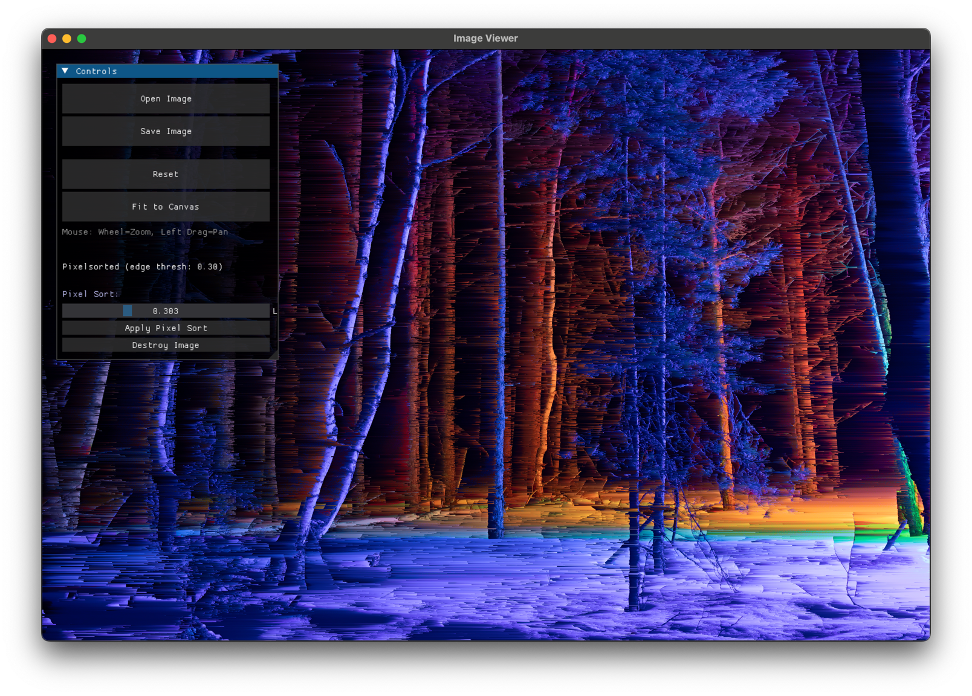# результаты и оригинал можно посмотреть в /DZ/_images

